**Project Design Phase**

**Solution Architecture**

|  |  |
| --- | --- |
| Date | 29 Jun 2025 |
| Team ID | LTVIP2025TMID47516 |
| Project Name | iRevolution: A Data-driven Exploration of Apple's iPhone Impact in India using Tableau |
| Maximum Marks | 4 Marks |

**Solution Architecture:**

**Problem Focus**: Lack of clear, data-driven insights on iPhone adoption, user behavior, and cultural impact in India.

**Data Collection**:

* Sales, demographics, and simulated social media sentiment data.
* Stored and managed in **IBM DB2**.

**Data Preparation**:

* Cleaned using **SQL** and **Python (Pandas, TextBlob)**.
* Processed for trend, sentiment, and preference analysis.

**Visualization Layer**:

* Built using **Tableau** for interactive dashboards.
* Includes trends, demographics, and cultural impact visualizations.

**Web Integration**:

* Dashboards and stories embedded into a **Flask-based web UI**.
* Enables accessible viewing and interaction for users.

**Scalable Design**:

* Can be extended with real-time data and adapted to other markets or products

**Example - Solution Architecture Diagram:**

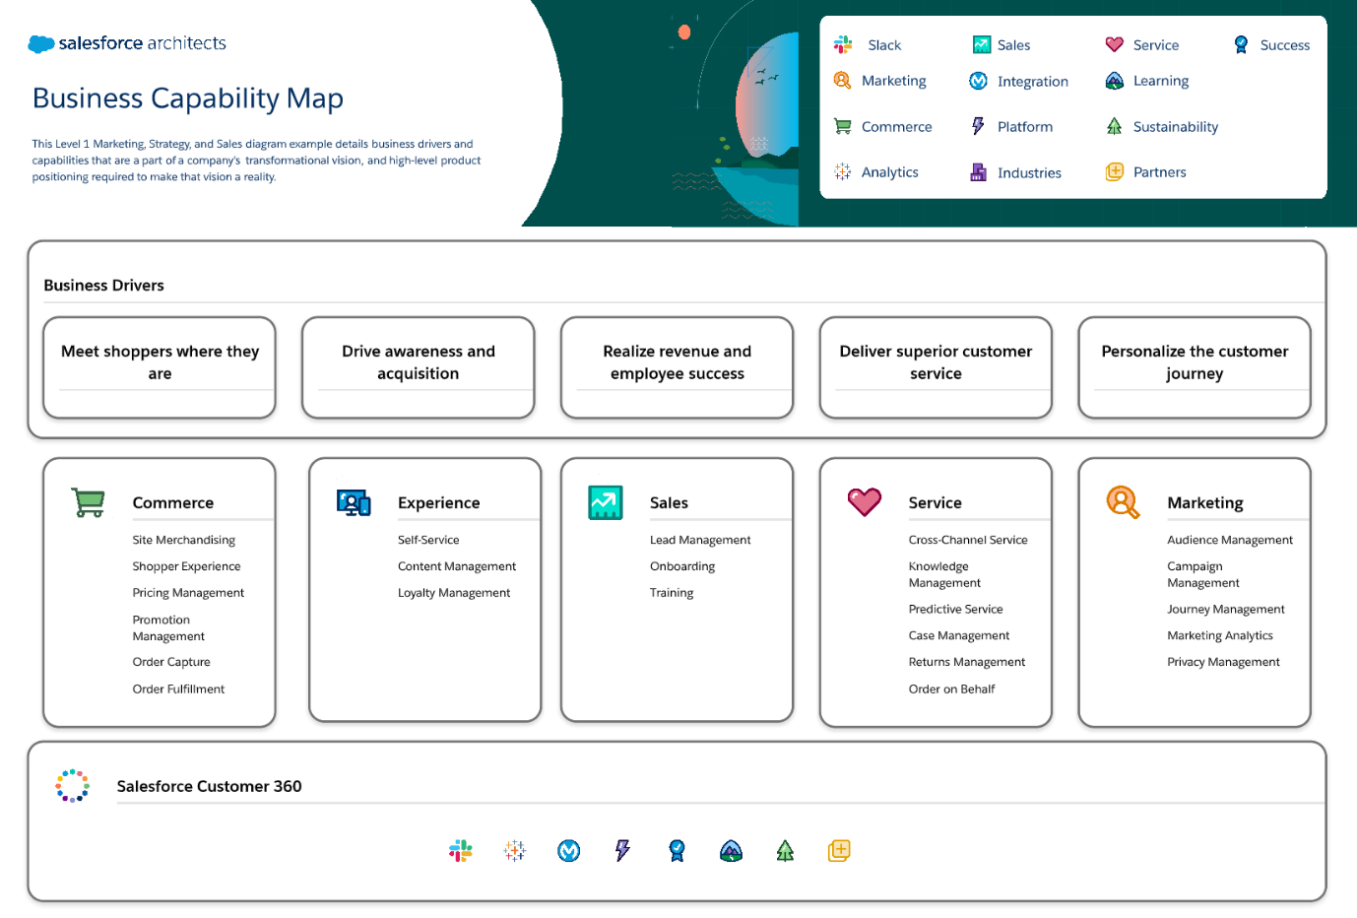

*Figure 1: Architecture and data flow of iPhone sales in india*